**HOTEL MANAGEMENT SYSTEM**

Roll No. : 9

Name: Fenil patel

Class: 12 – B

Subject: Computer Science

Subject Code: 083

Project Guide: Ms. Amisha Dalal



# CERTIFICATE

# Acknowledgements

# Apart from my efforts, the success of any project depends largely on the encouragement and guidelines of many others. I take this opportunity to express my gratitude to the people who have been instrumental in the successful completion of this project. I express deep sense of gratitude to the almighty God for giving me strength for the successful completion of the project. I express my heartfelt gratitude to my parents for constant encouragement while carrying out this project. I gratefully acknowledge the contribution of the individuals who contributed in bringing this project up to this level, who continue to look after me despite my flaws, I express my deep sense of gratitude to the iluminary, The Principal, Alpa Mathur who has been continuously motivating and extending her helping hand to us. I shall fail in my duty if I didn’t thank Ms. Amisha Dalal, Master In-charge, A guide, Mentor all the above a friend, who critically reviewed my project and helped in solving each and every problem, occurred during the implementation of the project The guidance and support received from all the members who contributed and who are contributing to this project, was vital for the success of the project. I am grateful for their constant support and help.

# Contents

1. Introduction of the Project.
2. System Requirements of the Project.
3. Python Coding.
4. Output of the Project.
5. References.

# Introduction of the Project

**The project starts with –**

Enter 1 - CUSTOMER DETAILS

Enter 2 - BOOKING RECORD

Enter 3 - ROOM RENT

Enter 4 - RESTAURENT BILL

Enter 5 - GAMING BILL

Enter 6 - FASHION STORE BILL

Enter 7 - DISPLAY CUSTOMER DETAILS

Enter 8 - TOTAL BILL

Enter 9 - OLD BILL

Enter 10- EXIT

# System Requirements of the Project

### Recommended System Requirements

Processors: Intel® Core™ i3 processor 4300M at 2.60 GHz. Disk space: 2 to 4 GB.

Operating systems: Windows® 10, MACOS, and UBUNTU. Python Versions: 3.X.X or Higher.

### Minimum System Requirements

Processors: Intel Atom® processor or Intel® Core™ i3 processor. Disk space: 1 GB.

Operating systems: Windows 7 or later, MACOS, and UBUNTU. Python Versions: 2.7.X, 3.6.X.

### Prerequisites before installing MySQL Connector Python

You need root or administrator privileges to perform the installation process.

Python must be installed on your machine.

Note: – MySQL Connector Python requires python to be in the system’s PATH. Installation fails if it doesn’t find Python.

On Windows, If Python doesn’t exist in the system’s PATH, please manually add the directory containing python.exe yourself.

**PYTHON CODING**

import mysql.connector

# GLOBAL VARIABLES DECLARATION

myConnnection ="" cursor="" userName="" password ="" roomrent =0 restaurentbill=0 gamingbill=0 fashionbill=0 totalAmount=0 cid=""

#MODULE TO CHECK MYSQL CONNECTIVITY

def MYSQLconnectionCheck (): global myConnection

global userName global password

userName = input("\n ENTER MYSQL SERVER'S USERNAME : ")

password = input("\n ENTER MYSQL SERVER'S PASSWORD : ")

myConnection=mysql.connector.connect(host="localhost",user=userName,passwd=password , auth_plugin='mysql_native_password' )

if myConnection:

print("\n CONGRATULATIONS ! YOUR MYSQL CONNECTION HAS BEEN ESTABLISHED !")

cursor=myConnection.cursor()

cursor.execute("CREATE DATABASE IF NOT EXISTS HMS")

cursor.execute("COMMIT") cursor.close()

return myConnection else:

print("\nERROR ESTABLISHING MYSQL CONNECTION CHECK USERNAME AND PASSWORD !")

#MODULE TO ESTABLISHED MYSQL CONNECTION

def MYSQLconnection () global userName global password global myConnection global cid

myConnection=mysql.connector.connect(host="localhost",user=userName,passwd=password , database="HMS" , auth_plugin='mysql_native_password' )

if myConnection:

return myConnection else:

print("\nERROR ESTABLISHING MYSQL CONNECTION !")

myConnection.close()

def userEntry(): global cid

if myConnection:

cursor=myConnection.cursor(

createTable ="""CREATE TABLE IF NOT EXISTS C_DETAILS(CID VARCHAR(20),C_NAME VARCHAR(30),C_ADDRESS VARCHAR(30),C_AGE VARCHAR(30),

C_COUNTRY VARCHAR(30) ,P_NO VARCHAR(30),C_EMAIL VARCHAR(30))”””

cursor.execute(createTable)

cid = input("Enter Customer Identification Number : ") name = input("Enter Customer Name : ")

address = input("Enter Customer Address : ") age= input("Enter Customer Age : ")

nationality = input("Enter Customer Country : ") phoneno= input("Enter Customer Contact Number : ") email = input("Enter Customer Email : ")

sql = "INSERT INTO C_Details VALUES(%s,%s,%s,%s,%s,%s,%s)" values= (cid,name,address,age,nationality,phoneno,email) cursor.execute(sql,values)

cursor.execute("COMMIT")

print("\nNew Customer Entered In The System Successfully !") cursor.close()

else:

print("\nERROR ESTABLISHING MYSQL CONNECTION !")

def bookingRecord():

global cid customer=searchCustomer() if customer:

if myConnection:

cursor=myConnection.cursor()

createTable ="CREATE TABLE IF NOT EXISTS BOOKING_RECORD(CID VARCHAR(20),CHECK_IN DATE ,CHECK_OUT DATE)"

cursor.execute(createTable)

checkin=input("\n Enter Customer CheckIN Date [ YYYY-MM-DD ] : ") checkout=input("\n Enter Customer CheckOUT Date [ YYYY-MM-DD ] : ") sql= "INSERT INTO BOOKING_RECORD VALUES(%s,%s,%s)"

values= (cid,checkin,checkout) cursor.execute(sql,values) cursor.execute("COMMIT")

print("\nCHECK-IN AND CHECK-OUT ENTRY MADED SUCCESSFULLY !")

cursor.close() else:

print("\nERROR ESTABLISHING MYSQL CONNECTION !")

def roomRent():

global cid customer=searchCustomer() if customer:

global roomrent if myConnection:

cursor=myConnection.cursor()

createTable ="""CREATE TABLE IF NOT EXISTS ROOM_RENT(CID VARCHAR(20),ROOM_CHOICE INT,NO_OF_DAYS INT,ROOMNO INT ,ROOMRENT INT)”””

cursor.execute(createTable)

print ("\n ##### We have The Following Rooms For You #####") print (" 1. Ultra Royal > 10000 Rs.")

print (" 2. Royal > 5000 Rs. ")

print (" 3. Elite > 3500 Rs. ")

print (" 4. Budget > 2500 USD ")

roomchoice =int(input("Enter Your Option : ")) roomno=int(input("Enter Customer Room No : ")) noofdays=int(input("Enter No. Of Days : "))

if roomchoice==1:

roomrent = noofdays * 10000

print("\nUltra Royal Room Rent : ",roomrent) elif roomchoice==2:

roomrent = noofdays * 5000 print("\nRoyal Room Rent : ",roomrent)

elif roomchoice==3:

roomrent = noofdays * 3500

print("\nElite Royal Room Rent : ",roomrent) elif roomchoice==4:

roomrent = noofdays * 2500 print("\nBudget Room Rent : ",roomrent)

else:

print("Sorry ,May Be You Are Giving Me Wrong Input, Please Try Again !!! ") return

sql= "INSERT INTO ROOM_RENT VALUES(%s,%s,%s,%s,%s)"

values= (cid,roomchoice,noofdays,roomno,roomrent,) cursor.execute(sql,values)

cursor.execute("COMMIT")

print("Thank You , Your Room Has Been Booked For : ",noofdays , "Days" ) print("Your Total Room Rent is : Rs. ",roomrent)

cursor.close() else:

print("\nERROR ESTABLISHING MYSQL CONNECTION !")

def Restaurent():

global cid customer=searchCustomer() if customer:

global restaurentbill if myConnection:

cursor=myConnection.cursor(

createTable ="""CREATE TABLE IF NOT EXISTS RESTAURENT(CID VARCHAR(20),CUISINE VARCHAR(30),QUANTITY VARCHAR(30),BILL VARCHAR(30))

"""

cursor.execute(createTable)

print("1. Vegetarian Combo > 300 Rs.")

print("2. Non-Vegetarian Combo > 500 Rs.")

print("3. Vegetarian & Non-Vegetarian Combo > 750 Rs.")

choice_dish = int(input("Enter Your Cusine : "))

quantity=int(input("Enter Quantity : ")) if choice_dish==1:

print("\nSO YOU HAVE ORDER: Vegetarian Combo ") restaurentbill = quantity * 300

elif choice_dish==2:

print("\nSO YOU HAVE ORDER: Non-Vegetarian Combo ") restaurentbill = quantity * 500

elif choice_dish==3:

print("\nSO YOU HAVE ORDER: Vegetarian & Non-Vegetarian Combo ") restaurentbill= quantity * 750

else:

print("Sorry ,May Be You Are Giving Me Wrong Input, Please Try Again !!! ") return

sql= "INSERT INTO RESTAURENT VALUES(%s,%s,%s,%s)"

values= (cid,choice_dish,quantity,restaurentbill) cursor.execute(sql,values) cursor.execute("COMMIT")

print("Your Total Bill Amount Is : Rs. ",restaurentbill) print("\n\n**** WE HOPE YOU WILL ENJOY YOUR MEAL ***\n\n" ) cursor.close()

else:

print("\nERROR ESTABLISHING MYSQL CONNECTION !")

def Gaming():

global cid customer=searchCustomer() if customer:

global gamingbill if myConnection:

cursor=myConnection.cursor()

createTable ="""CREATE TABLE IF NOT EXISTS GAMING(CID VARCHAR(20),GAMES VARCHAR(30),HOURS VARCHAR(30),GAMING_BILL VARCHAR(30))

""" cursor.execute(createTable) print("""

1. Table Tennis > 150 Rs./HR
2. Bowling > 100 Rs./HR
3. Snooker > 250 Rs./HR
4. VR World Gaming > 400 Rs./HR
5. Video Games > 300 Rs./HR
6. Swimming Pool Games -----> 350 Rs./HR
7. Exit

""")

game=int(input("Enter What Game You Want To Play : ")) hour=int(input("Enter No Of Hours You Want To Play : ")) print("\n\n#################################################")

if game==1:

print("YOU HAVE SELECTED TO PLAY : Table Tennis") gamingbill = hour * 150

elif game==2:

print("YOU HAVE SELECTED TO PLAY : Bowling")

gamingbill = hour * 100 elif game==3:

print("YOU HAVE SELECTED TO PLAY : Snooker")

gamingbill = hour * 250 elif game==4:

print("YOU HAVE SELECTED TO PLAY : VR World Gaming") gamingbill = hour * 400

elif game==5:

print("YOU HAVE SELECTED TO PLAY : Video Games") gamingbill = hour * 300

elif game ==6:

print("YOU HAVE SELECTED TO PLAY : Swimming Pool Games") gamingbill = hour * 350

else:

print("Sorry ,May Be You Are Giving Me Wrong Input, Please Try Again !!! ") return

sql= "INSERT INTO GAMING VALUES(%s,%s,%s,%s)"

values= (cid,game,hour,gamingbill) cursor.execute(sql,values) cursor.execute("COMMIT")

print("Your Total Gaming Bill Is : Rs. ",gamingbill)

print("FOR : ",hour," HOURS","\n *** WE HOPE YOU WILL ENJOY YOUR GAME ***") print("\n\n#################################################")

cursor.close() else:

print("ERROR ESTABLISHING MYSQL CONNECTION !")

def Fashion():

global cid customer=searchCustomer() if customer:

global fashionbill if myConnection:

cursor=myConnection.cursor()

createTable ="""CREATE TABLE IF NOT EXISTS FASHION(CID VARCHAR(20),DRESS VARCHAR(30),AMOUNT VARCHAR(30),BILL VARCHAR(30))”””

cursor.execute(createTable) print("""

1. Shirts > 1500 Rs.
2. T-Shirts > 300 Rs.
3. Pants > 2000 Rs.
4. Jeans > 4000 Rs.
5. Tassel top > 500 Rs.
6. Gown > 3000 Rs.
7. Western dress > 3000 Rs.
8. Skirts > 400 Rs.
9. Trousers > 200 Rs.
10. InnerWear > 30 Rs.

""")

dress=int(input("Enter the your Choice wear: ")) quantity=int(input("How many you want to buy: ")) if dress==1:

print("\nShirts")

fashionbill = quantity * 1500 elif dress==2:

print("\nT-Shirts") fashionbill = quantity * 300

elif dress==3: print("\nPants")

fashionbill = quantity * 2000 elif dress==4:

print("\nJeans")

fashionbill = quantity * 4000 elif dress==5:

print("\nTassel top") fashionbill = quantity * 500

elif dress==6: print("\nGown")

fashionbill = quantity * 3000 elif dress==7:

print("\nWestern dress") fashionbill = quantity * 3000

elif dress==8: print("\nSkirts")

fashionbill = quantity * 400 elif dress==9:

print("\nTrousers") fashionbill = quantity * 200

elif dress==10: print("\nInnerWear") fashionbill = quantity * 30

else:

print("Sorry ,May Be You Are Giving Me Wrong Input, Please Try Again !!! ") return

sql= "INSERT INTO FASHION VALUES(%s,%s,%s,%s)"

values= (cid,dress,quantity,fashionbill) cursor.execute(sql,values) cursor.execute("COMMIT")

print("\n\n#################################################")

print("\nYOU SELECT ITEM NO : ",dress,"\nYOUR QUANTITY IS : ",quantity," ITEMS","\nTHANK YOU FOR SHOPPING VISIT AGAIN!!!" )

print("\nYour Total Bill Is : ",fashionbill) print("\n\n#################################################")

cursor.close() else:

print("\nERROR ESTABLISHING MYSQL CONNECTION !")

def totalAmount(): global cid

customer=searchCustomer() if customer:

global grandTotal global roomrent global restaurentbill global fashionbill global gamingbill

if myConnection: cursor=myConnection.cursor()

createTable ="""CREATE TABLE IF NOT EXISTS TOTAL(CID VARCHAR(20),C_NAME VARCHAR(30),ROOMRENT INT ,RESTAURENTBILL INT ,GAMINGBILL INT,FASHIONBILL INT,TOTALAMOUNT INT)"""

cursor.execute(createTable)

sql= "INSERT INTO TOTAL VALUES(%s,%s,%s,%s,%s,%s,%s)"

name = input("Enter Customer Name : ") grandTotal=roomrent + restaurentbill + fashionbill + gamingbill

values= (cid,name,roomrent,restaurentbill , gamingbill,fashionbill,grandTotal) cursor.execute(sql,values)

cursor.execute("COMMIT") cursor.close()

print("\n **** CROWN PLAZA MIAMI **** CUSTOMER BIILING ****") print("\n CUSTOMER NAME : " ,name)

print("\nROOM RENT : Rs. ",roomrent) print("\nRESTAURENT BILL : Rs. ",restaurentbill) print("\nFASHION BILL : Rs. ",fashionbill) print("\nGAMING BILL : Rs. ",gamingbill)

print(" ") print("\nTOTAL AMOUNT : Rs. ",grandTotal)

cursor.close() else:

print("\nERROR ESTABLISHING MYSQL CONNECTION !")

def searchOldBill():

global cid customer=searchCustomer() if customer:

if myConnection: cursor=myConnection.cursor()

sql="SELECT * FROM TOTAL WHERE CID= %s"

cursor.execute(sql,(cid,))

data=cursor.fetchall() if data:

print(data) else:

print("Record Not Found Try Again !") cursor.close()

else:

print("\nSomthing Went Wrong ,Please Try Again !")

def searchCustomer(): global cid

if myConnection: cursor=myConnection.cursor() cid=input("ENTER CUSTOMER ID : ")

sql="SELECT * FROM C_DETAILS WHERE CID= %s"

cursor.execute(sql,(cid,)) data=cursor.fetchall()

if data:

print(data) return True

else:

print("Record Not Found Try Again !") return False

cursor.close()

else:

print("\nSomthing Went Wrong ,Please Try Again !")

myConnection = MYSQLconnectionCheck () if myConnection:

MYSQLconnection () while(True):

print("""

1--->Enter Customer Details 2--->Booking Record

3--->Calculate Room Rent

4--->Calculate Restaurant Bill 5--->Calculate Gaming Bill

6--->Calculate Fashion store Bill 7--->Display Customer Details

1. -->GENERATE TOTAL BILL AMOUNT
2. -->GENERATE OLD BILL
3. -->EXIT """)

choice = int(input("Enter Your Choice")) if choice == 1:

userEntry() elif choice ==2:

bookingRecord()

elif choice ==3:

roomRent() elif choice ==4:

Restaurent() elif choice ==5:

Gaming() elif choice ==6:

Fashion() elif choice ==7:

searchCustomer() elif choice ==8:

totalAmount() elif choice ==9:

searchOldBill() elif choice ==10:

break else:

print("Sorry ,May Be You Are Giving Me Wrong Input, Please Try Again !!! ")

else:

print("\nERROR ESTABLISHING MYSQL CONNECTION !") # END OF PROJECT

**USER AUTHENTICATION**

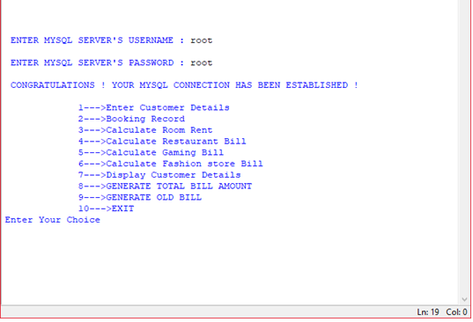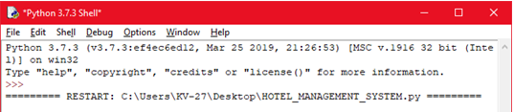

**CUSTOMER DETAILS**

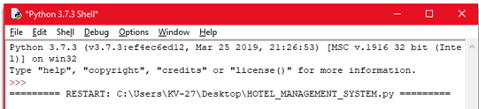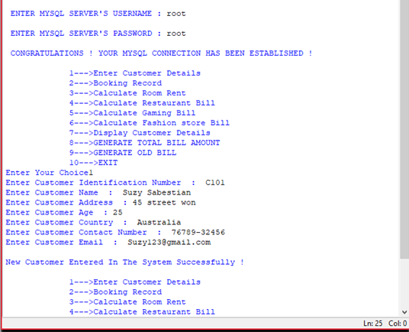

**CUSTOMER BOOKING RECORDS**

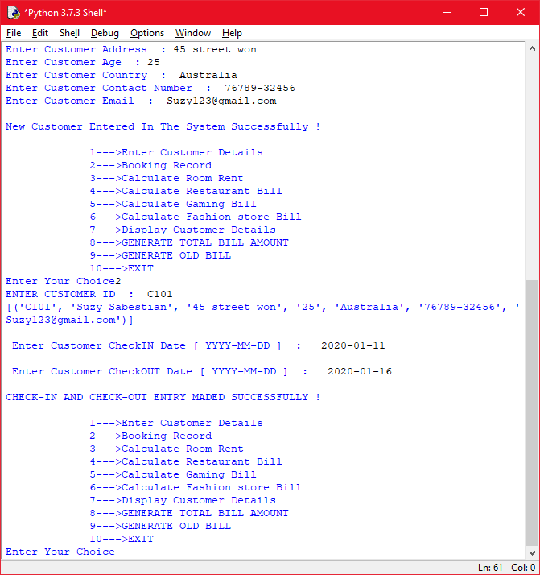

**ROOM RENT**

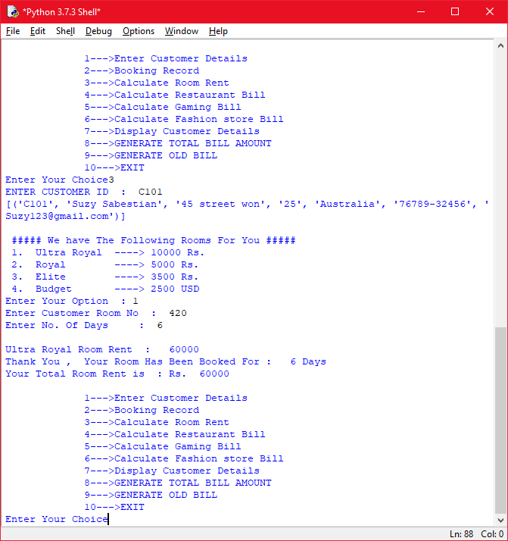

**RESTAURENT BILL**

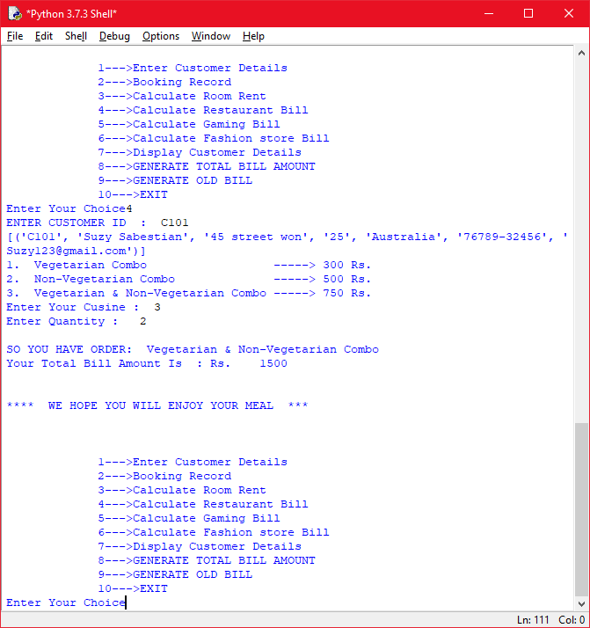

**GAMING BILL**

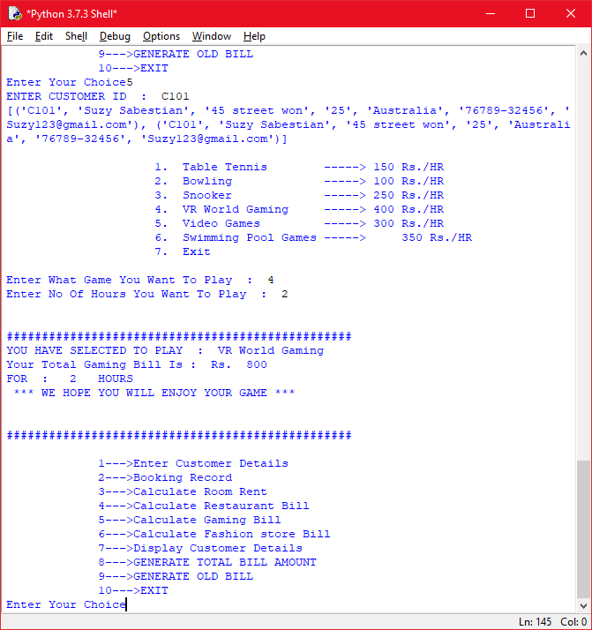

**FASHION STORE BILL**

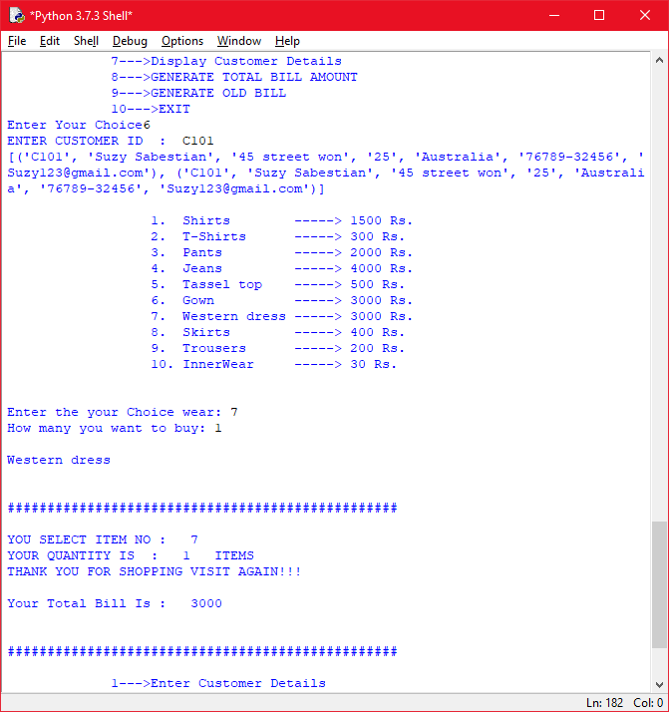

**DETAILS OF THE CUSTOMER**

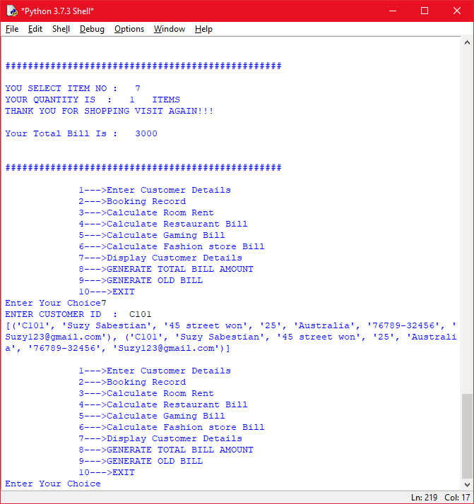

**TOTAL BILL**

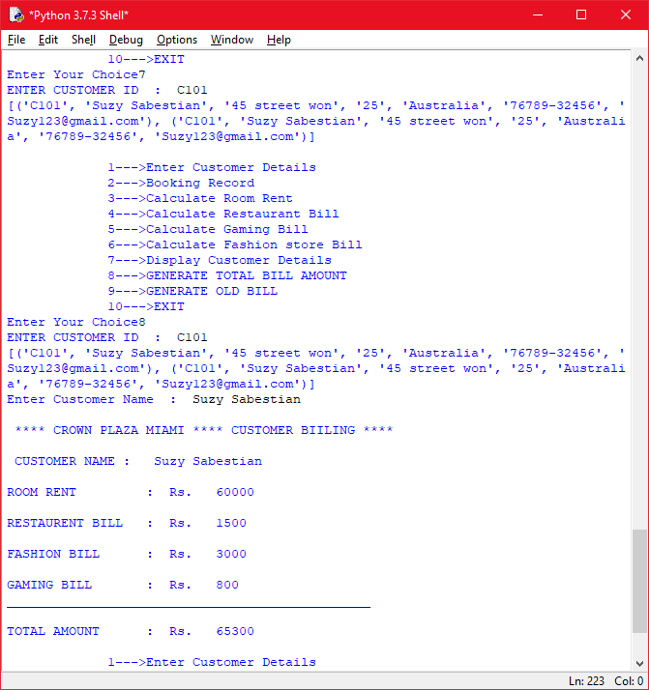

**OLD BILL**

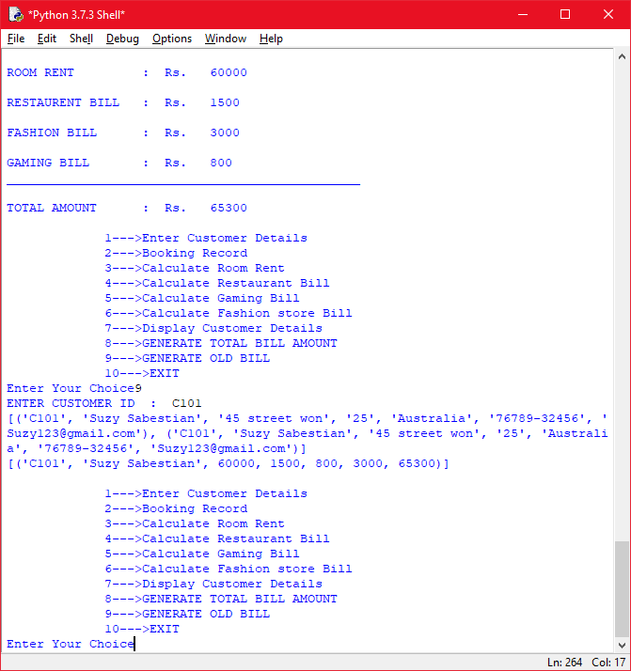

**EXIT**

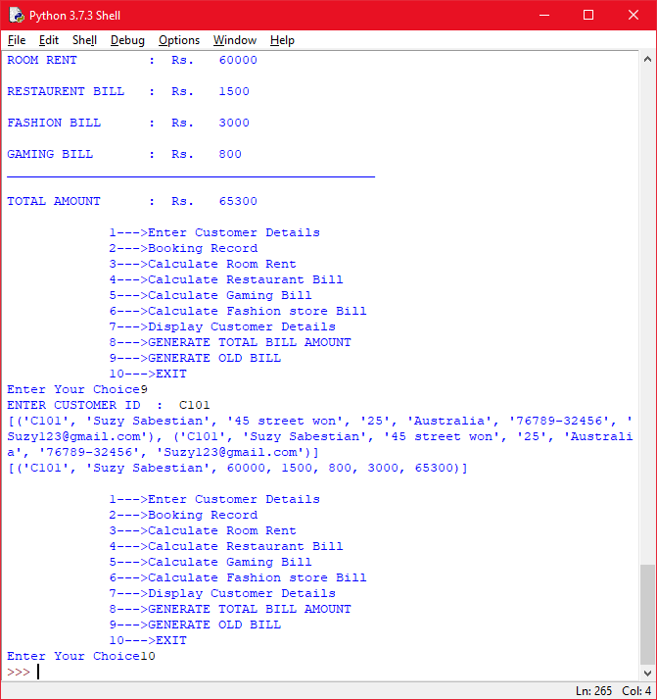

**MYSQL DATABASE AND TABLES USED IN THIS PROJECT**

**DATABASE**

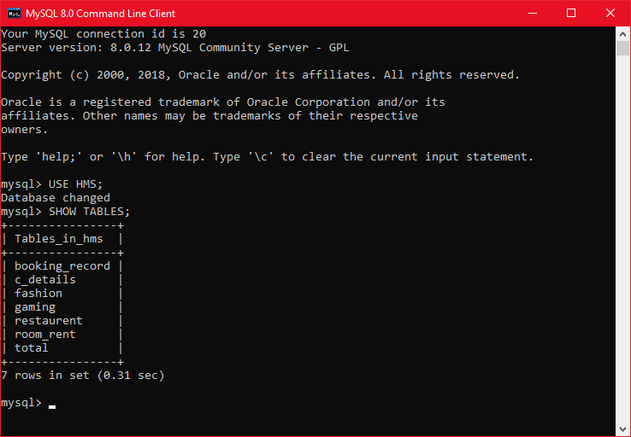

**TABLE STRUCTURE 1 AND 2**

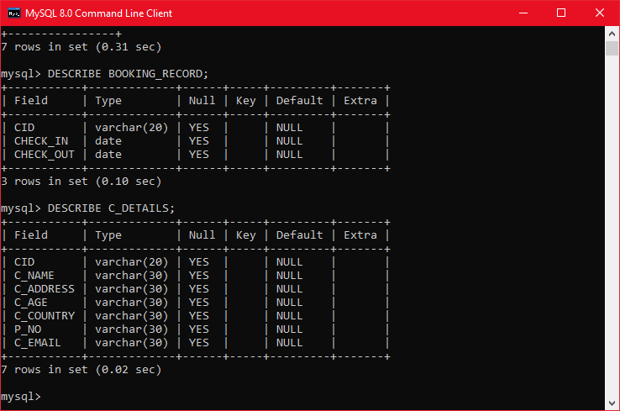

**TABLE STRUCTURE 3 AND 4**

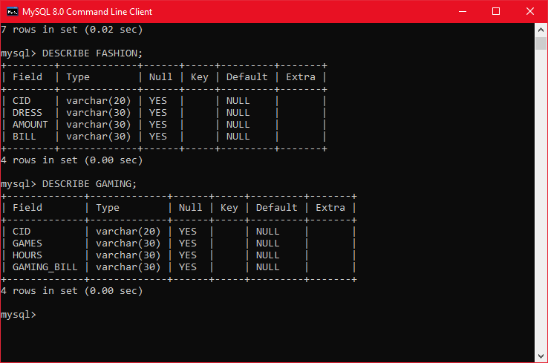

**TABLE STRUCTURE 5 AND 6**

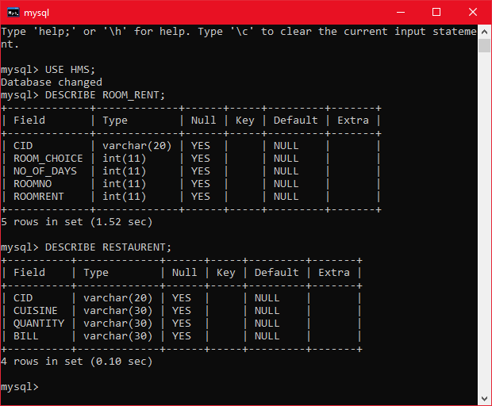

**TABLE STRUCTURE 7**

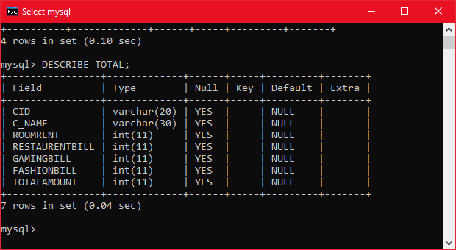

***BACKEND DATA GENERATED THROUGH SOFTWARE***

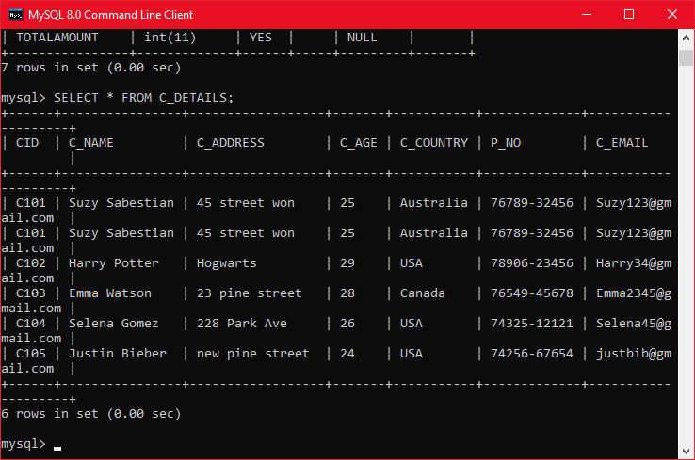

***BACKEND DATA GENERATED THROUGH SOFTWARE***

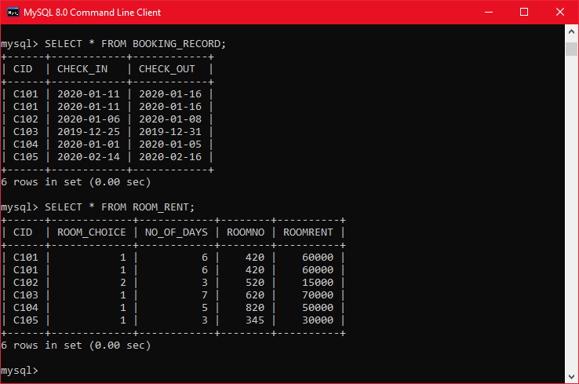

**BACKEND DATA GENERATED THROUGH SOFTWARE**

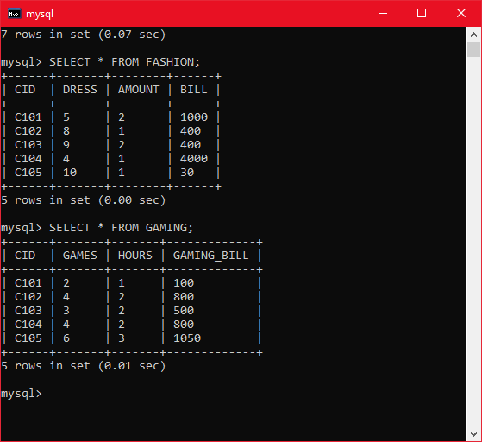

***BACKEND DATA GENERATED THROUGH SOFTWARE***

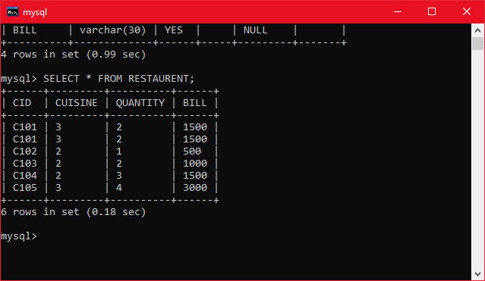

***BACKEND DATA GENERATED THROUGH SOFTWARE***

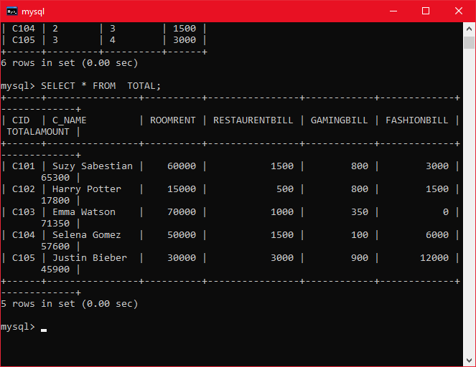

# References

1. python.org
2. Code Academy
3. tutorialsPoint.com
4. PythonChallenge.com
5. Google’s Python Class
6. LearnPython.org
7. layak.in